Purpose
This document describes the development of dimensional measurement and cosmetical inspection equipment, (computerized systems hardware and software) within Vision Engineering.

This includes:
- Project management and quality methods.
- Software development toolchain.
- Handling of created or sourced hardware and software components.
- Test management.
- Deliverables for interfacing processes.

This SOP is in accordance with the Technology Development Process [01] and covers the requirements of the Validation and Qualification Guideline [02], IT Validation Guideline [03] and the Data Integrity Guideline for Computerized Systems [04].

Scope
Systems developed or changed in the Vision Engineering Team at SCHOTT Pharma Schweiz AG for the purpose of in-line and off-line inspection of primary packaging for Pharma and/or cosmetic Application.
Table of Content
1 Purpose 1
2 Scope 1
3 Introduction 3
4 Responsibilities 4
5 Abbreviations and Definitions 4
6 Procedure 5
6.1 SIPOC 5
6.2 Flowchart 6
7 Methods 7
7.1 Draft solutions 7
7.2 Feasibility Study 7
7.3 Work packages 7
7.4 First device(s) 11
7.5 Qualification and Validation support 11
7.6 Industrialization 11
8 Input/ Output/ KPIs 11
9 Documentation 12
10 Training 12
11 Applicable standards 13
12 Reference Documents 13
13 Document History 13

Introduction
The quality of the products is agreed upon with the customer and the defects are listed in a product specific defect catalogue with their criticality. Vision Engineering develops measurement systems for those (and other) dimensional and cosmetical defects. Developed features are selected based on strategic decision making. Vision Engineering takes measures to improve the detection performance of the measurement systems. This document gives guidance on the procedure for each development project.
Systems at Vision Engineering are developed with well-established concepts like DevOps and SCRUM. DevOps is a software development methodology that emphasizes collaboration and integration between software development (Dev) and IT operations (Ops) teams. It aims to streamline the software delivery process, increase efficiency, and improve product quality through continuous integration, continuous and cosmetical delivery, and continuous deployment practices. DevOps promotes a culture of automation, monitoring, and sharing feedback loops to enable rapid iteration and faster time to market.
For Vision Engineering, this is achieved by the following steps:
- Viable solutions are drafted and evaluated.
- A solution is selected based on a Feasibility Study.
- Work packages are defined and realized.
- A prototype is built and tests are conducted.
- Delivery of the first device(s)
- Qualification support
- Industrialization: Completing the project and listing for order.

Scrum is a framework for agile project management. For Vision Engineering, this means:
- Iterative and incremental development
- Self-organizing, cross functional teams
- Frequent feedback and adjustment

A toolchain was developed to help ensure compliance with processes, customer requirements, design principles, good practices, and regulations. The toolchain enforces consistent quality of the produced software. The following elements are part of the toolchain:
- Requirements, Test Cases and Test Reports are created in Helix ALM.
- Risk Analysis is created in Plato SCIO.
- Coding is done in Visual Studio. If necessary, code libraries will be used.
- Software code is managed using GIT (on a MS Azure Server), inlcuding automated version control. The code quality is checked automatically with ReSharper and custom Unit Tests with NUnit.
- The system is continuously tested while development (embedded testing) and the results are documented in Helix ALM.
- The functional complete software is made into a Release Candidate (e.g.: Installer is created). Integration Testing, Acceptance Testing and Regression Testing is performed. The tests and Issue Management are documented in Helix ALM.
- The released software is then stored in the Nexus repository manager for deployment.
This toolchain prevents unintended changes, provides secure data locations and user management, where necessary.
The following chapters give an overview of typical roles, responsibilities, methods, and outputs of development of measurement systems within Vision Engineering.

Responsibilities
Table 1: Responsibilities
Responsibility | Function/ department
Owner of procedure | Head of Vision Engineering,
Procedure team of the Vision engineering organization | Software Engineer  Software Tester  Project Leader  Process Engineer

Abbreviations and Definitions
For a list of abbreviations and definitions relevant for SCHOTT Pharma, please see ‘List of Abbreviations for SCHOTT P Unit’ (Doc ID: 10000410346).
Abbreviations specifically relevant for this document are listed in the table below.
Table 2: Abbreviations and Definitions
Term | Explanation
Acceptance Test | Formal test with pre-defined acceptance criteria to form a conclusion whether the software is accepted or not.
Code Review / Static Code Analysis | Independent review of the written code by another developer or automated system.
Configurable Software | (Commercial) off-the-shelf software that can be configured for specific user applications without altering the basic program
Configuration | state-specific modifications related to the part of the software which is not the source code (software binaries) or changes of structural data model
COTS | Commercial off the shelf software.
CSV | Computerized System Validation.
DevOps | A software development approach to streamline and automate software delivery and achieve faster, more reliable development and deployment.
IDE | Integrated Development Environment. A software solution to conduct the coding.
Integration Test | Formal test of the software within the intended environment.
GAMP | Good Automated Manufacturing Practice.
Git | A “distributed version control system” to track changes in a set of computer files.
Opportunity change / opportunistic change | Adjustments made to the software that were not originally part of the project scope but were introduced during the project due to favorable circumstances, e.g., bug fixes. May not be based on a formally released URS. The adjustments have been requested during the life cycle of the software and were collected for later implementation.
Regression Test | Test to ensure that the previously existing functionality was not affected.
Software Deployment Package | Package of the software and all required components, third party software and libraries.
SCIO | Software solution for FMEAs from the company PLATO.
SOUP | Software of unknown provenance, for example code libraries or open-source software.
Unit Test | Test function to test a specific part of the source code.

Procedure

SIPOC
Supplier | Inputs | Process | Output | Customer
SteeCo | Project assignment | Project start | Project Charter,  Rough Concept | VE-Software or VE-Hardware Team
? | Predecessor device or software | Draft solution | Concept | ?
? | Concept | Feasibility study | Cost calculation,  Effort estimates in h,  Feasibility Report … | ?
VE Team,  Process Owner | Concept of drafted Version,  URS,  Customer requirements, Function specification,  GAP Analysis | Define Work Packages | User stories,  Risk assessment,  Testing strategies,  Make or Buy decisions,  Hardware development,  Calibration  MSA | VE Team HW,  Customer, SteeCo
 |  |  | User stories,  Risk assessment,  Testing strategies,  Coding (Versioning),  Calibration  MSA | VE Team SW,  Customer, SteeCo
VE Team HW,  Customer, SteeCo | User stories,  Risk assessment,  Testing strategies  Make or Buy decisions,  Hardware development,  System Integration | Close Work Packages | Functional model (Hardware), | VE Team HW,  Customer
VE Team SW,  Customer, SteeCo | User stories,  Risk assessment,  Testing strategies  System Integration  Coding (Versioning)  Functional model (Hardware simulation),  Software simulation  Calibration  MSA |  | Software on alpha or beta version | VE Team SW,  Customer
VE Team HW, | Hardware | Embedded Testing | Prototype | VE Team HW,  Customer
VE Team SW, | Software on alpha or beta version,  Static Code Review,  Unit Test, Acceptance tests, regression tests, integration tests, |  | Functional complete software (Release Candidate) | VE Team SW,  Customer
VE Team | Qualified and calibrated Prototype,  MSA  &  Functional complete software (Release Candidate) | Testing | First device  &  Software-Release | Validation Engineer, Customer
VE Team | Documented evidence e.g. ^calibration certificate, measuring point directory,  MSA | Qualification Support | Qualified first device / device  &  Validated Software; | Validation Engineer, Customer
VE Team | Updated FMEA | Industrialization | Project closed,  Lesson learned,  Update database,  Handover protocol | Life Cycle Management
- | - | Lifecycle and Maintenance of developed Systems | - | -

Flowchart
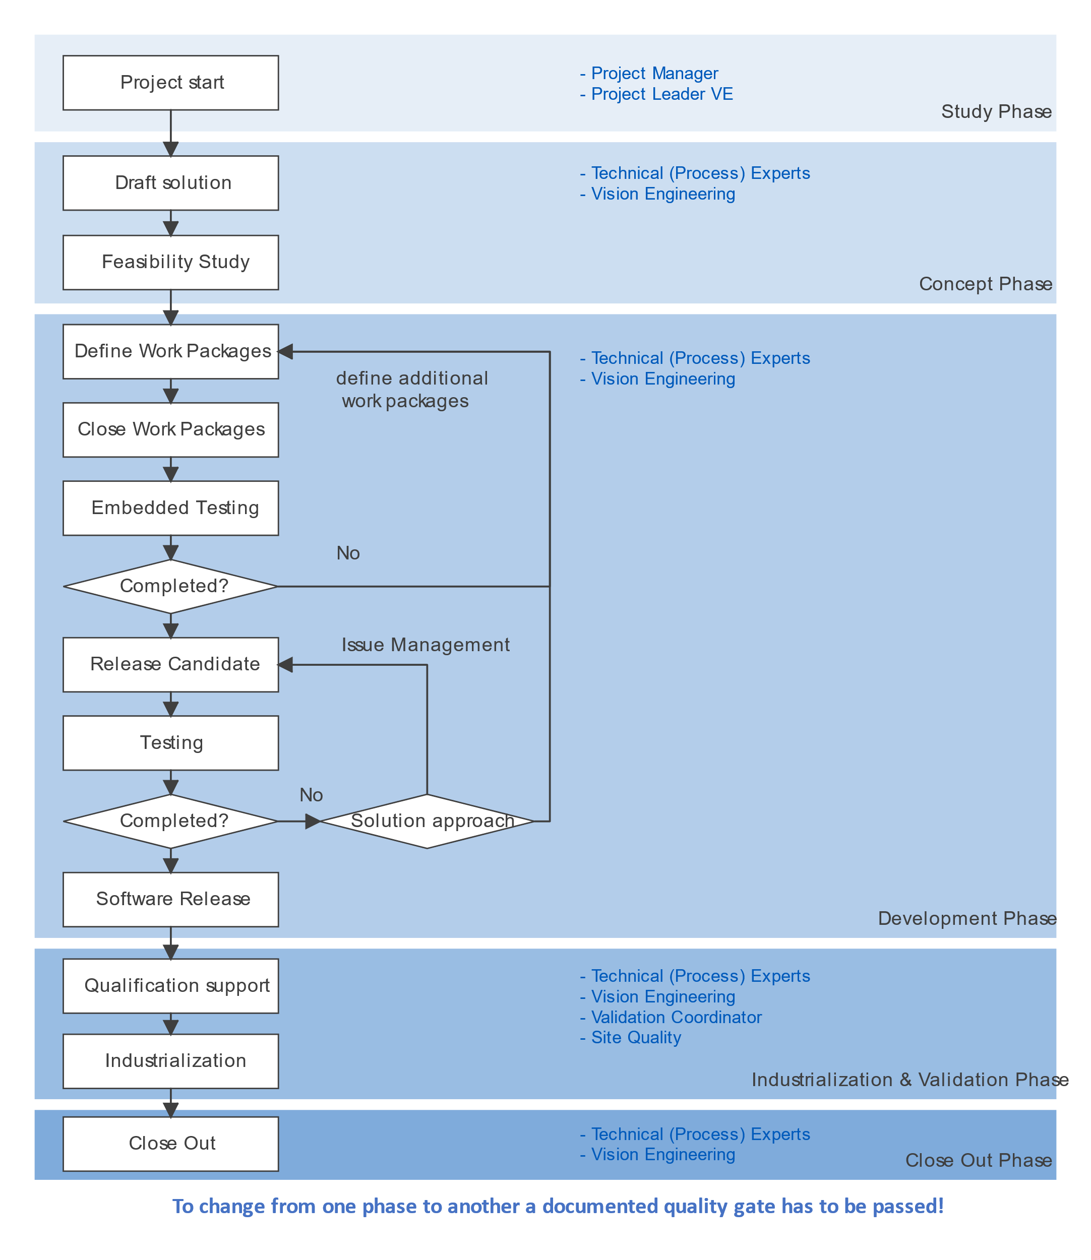

Methods
The following subchapters provide an overview of the methods commonly used during development. Which methods are used is decided ad hoc during development. Development occurs during the whole life cycle of a measurement system. A measurement system is only brought into a productive environment after a development project has been successfully completed or under strict rules for releasing the produced products. Both cases must be planned and agreed upon with the project team, consisting at least of a project leader, technical expert, and quality representative.

Draft solutions
Key components to fulfil the requirements and the interfaces with each other are identified. Opportunity changes might be evaluated as well. It is defined how the components will interact with each other.
If possible, a predecessor device or software is selected. The solution shall be cost effective, simple, and easily available. If necessary, service shall be available on a global basis.

Feasibility Study
A feasibility study is conducted to demonstrate the functionality of a drafted solution. The following minimum content of a feasibility study must be provided:
- Cost calculation.
- Estimated project hours.
- Feasibility Report

Work packages
Work packages are derived from the drafted solution and the already realized progress. Work packages are agreed upon with the team members in short development cycles. The following subchapters are exemplary work packages, which can be done in any order necessary and in parallel:

User stories
User stories are created to define the expected behavior of the device or software from a user’s point of view. This helps the team to understand the requirements.

Risk Management
For identifying the technical and project-related main risks, risk analysis methods are used.

Testing strategies / Test Cases
A testing strategy is defined early in the project to make sure all user requirements are addressed. Test scenarios and their acceptance criteria are defined in Test Cases. During development, testing is done to iteratively to finalize the code by eliminating errors. Embedded Testing has been established as a term for this testing phase (see 7.3.12). After the software has been functionally completed, a Release Candidate is created, and a series of tests is conducted or collected to create the release documentation. See chapters 7.3.14 to 7.3.22.

Make or buy decisions
Hardware and software components may also be sourced from any supplier. For this decision, the technical challenges, price, project schedule and availability of resources may be considered.

Hardware development
New or changed hardware components are often part of the design output. The necessary changes are either part of the drafted solution or introduced during the project. Whenever a hardware component is part of the project the following documentation must be provided/updated:
- Drawing(s)
- Bill of Materials
- Checklist integration at site
- Trigger of the necessary global change process.

System Integration
Some hardware components have actuators or sensors which connect to the controller of the measurement system. Depending on the complexity and importance of those components appropriate measures must be taken to make sure that the components are working properly.

Coding
The work packages are broken down into smaller tasks and are implemented in the order the team agrees upon in the daily meetings. It is recommended to functionally complete units before switching topics. This way, testing can already be conducted, and fixes can be applied while the developer is still focused on the topic. Coding is done utilizing an IDE (Integrated Development Environment), for example Visual Studio. Whenever code changes are made, the functionality must be tested.

Versioning
The version number is defined by four individually counted numbers starting at 0:
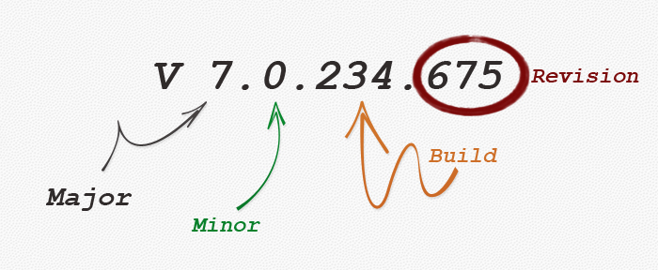
New revision numbers are automatically created for each upload of code snippets to Git.
Build numbers indicate that a new functional complete unit was compiled for testing.
A minor release indicates that new features have been implemented with a completed project.
Major releases indicate larger changes to the software. The first fully released version of each software would be V 1.0.x.x. The build and revision number are x in this case, because it is possible that fixes were implemented with the release candidate.

Functional model (Hardware simulation)
A functional hardware model can be used to test features and demonstrate the progress to the customer. A functional hardware model can consist of:
- Components of the final device.
- Custom components for handling products.
- Fixtures, actuators, sensors, transmissions, and similar components.

Software simulation
If necessary, a software simulation can be used to test features and demonstrate the progress to the customer. Software simulations typically simulate a complete device, communication interfaces to other devices, to a line controller or Manufacturing Execution System.

Calibration
Whenever measurement tests are performed on hardware, it must be checked if a calibration is necessary to produce reliable results. In most cases, this might not be necessary. For example, testing a change in the algorithm could produce many test cases, of which only a few are relevant for calibration.

Measurement System Analysis
While calibration estimates and corrects the performance of the measurement system in general, a Measurement System Analysis estimates the performance of for the specific measurement task (with the glass or polymer product) on an already calibrated system.

Embedded Testing
Tests conducted on Alpha or Beta versions (see 7.3.13) during the development of the software. These tests are not representative for the final software product, because the coding is still ongoing after the tests. Embedded Testing is a crucial part of development and reduces the errors found in later stages of the project. In general, the same Test Cases (and more) are covered in the Acceptance Testing or Integration Testing.

Alpha / Beta versions
Software builds created before the software is functional complete.

Functional complete software
Functional complete software has the following characteristics:
- Contains all modifications to fulfil the User requirements.
- Contains all additional necessary modifications requested or found during the development.
- Has successfully completed Static Code Review, Unit Test and Embedded Testing with no relevant errors remaining.

Prototype
A prototype device shall be used for testing of the functional complete software. The prototype device shall be physically and functionally as close as possible to the final measurement system. Ideally, a dedicated and complete measurement system for testing is kept for this purpose.

Qualification for Testing
The required state of the prototype for conducting tests with a release candidate must be documented and before conducting any tests for the purpose of releasing the software. It must be documented if the required state was achieved for this device. With this measure it is guaranteed that the device was qualified for testing. For example:
Table 3: Qualifying equipment for software testing (Example)
 | Required state | Test Evidence | Test Pass / Fail | Date / Visum
Base system hardware | TOPPAC-AIS Gen. 4 | Serial No. xy
Modifications | Additional GPU  Profinet interface | Type xy  […]
Pre-installed software | TOPPAC-AIS V5.3.2353.422  Updated Win-Image for IPC | Version xy  Version xy

Release Candidate
The functional complete software can be turned into a Release Candidate (RC). A full set of Test Cases as defined in the test strategy is conducted with the Release Candidate to demonstrate the functionality and quality of the software. To guarantee that the results are representative and reproduceable, the following measures must be taken:
- Only use qualified measurement system prototypes for testing.
- Uninstall pre-existing versions of the software. Check if all components are uninstalled successfully.
- Use the official installation instructions to conduct a fresh installation of the software.
- Check the conformity of the installation on the prototype device.
- Make sure the prototype device is calibrated.

Code review / ReSharper
Produced code must be checked for their correctness. Several software tools can be used for this reason. Visual Studio used in Vision Engineering has an integrated spellchecker and additionally a ReSharper plugin from JetBrains. If another IDE is used, it must be checked if the code review is sufficient. Code reviews can also be done by another individual.

Unit Tests
Functional units can often be tested with simple tests, to check if they are still functional and give a valid result after new code has been added. Unit Tests are created manually and are automatically executed with each new build.

Acceptance Tests
Modifications or new coding done to fulfil User Requirements are tested on a prototype or measurement system. The test description is stored in a Test Case in Helix. The test results are stored in a Test Report. If a test fails, a fix must be applied, and the test must be repeated. The corresponding test results are linked to the same Test Case with a new identification number.

Regression Tests
When pre-existing code is changed or complemented, there’s a chance that new errors are introduced that affect pre-existing functionality. Precautions can be taken during coding to reduce the occurrence of these errors, but to deliver conclusive evidence, tests have to be conducted. Regression Tests should always be conducted at the very end of the testing phase to make sure all bugfixes are covered as well.

Integration Tests
Other functional aspects of the system, safety features and Maintenance procedures are tested with Integration Tests.

Software Release
The Software Release marks the end of the software development. The following information must be provided to the project team:
- Software version
- Type of the Software Deployment Package
- Distribution Method / Storage Location
- Summary of the conducted testing.
- Change Log

First device(s)
The First device is a final measurement equipment, for productive use in a production facility. Depending on the scope of the project, multiple equipment can be regarded as First Devices. After a project is completed (Validation closed, Industrialization closed) the future devices are ready for roll out and are not regarded as First devices anymore.

Qualification and Validation support
Generally, qualification and validation documentation are in the responsibility of Vision Engineering. The necessary documentation will be prepared by a Validation Engineer. To prepare the qualification, it is necessary that Vision Engineering provides support throughout the whole project, beginning with the concept phase. According to the SOP 10000011139 IT Validation Guideline, Design Qualification will immediately start after the Software Release statement was given by Vision Engineering. The execution of the test protocols can either be done by the Validation Engineer, site operations staff, or appropriately trained members of the development team. When technical expertise is required to conduct the qualification and validation tests (e.g.: when new user interfaces are introduced), the tests are typically conducted by the development team.
Note: Qualification and Validation is the documented evidence, that the system was developed correctly and under appropriate assumptions. Qualification and Validation documents serve as the essential bridge to compliance with legal requirements in the pharmaceutical sector. These documents adhere to Good Documentation Practice and are change controlled.

Industrialization
After the qualification and validation is closed, the measurement system must be made available for order and the project must be formally closed. This includes creation/maintenance of the items and objects in SAP, update of the knowledge database, lessons learned and similar activities.

Lifecycle and Maintenance of Developed Systems
In general, this SOP applies to the development of systems with projects. If Change Requests for existing systems are required, the affected system must be covered by risk assessment and appropriate tests have to be planned to check if the system is still valid after the change has been conducted.

Input/ Output/ KPIs
Input: Idea description or Project description
Output: Valid Automated Inspection System, Measurement Device or Software.
KPIs: No specific KPI is defined for the process.

Documentation
Documents created during this procedure are created on various systems (Table 4).
Q/V relevant document outputs are collected, labelled according to Good Documentation Practice, and attached to the corresponding qualification and validation documents, where necessary.

Table 4 List of regularly used software within Vision Engineering
System | Originator | Purpose | Quality relevant files
.NET Framework | Microsoft Corporation | Coding | None
Adobe Sign | Adobe Inc. | Digital signatures | Signed PDFs
Azure DevOps Server | Microsoft Corporation | Project Management | None
Confluence | Atlassian | Wiki Software | None
Git | Junio Hamano, Linus Torvalds, Shawn Pearce | Version control | None
Helix ALM | Perforce Software Inc. | Software Testing, Traceability, Issue Management | Print out with signature*
Jira | Atlassian | Project Management | None
Microsoft Azure | Microsoft Corporation | Cloud software | None
Nexus repository manager | Sonatype | Version control | Backup / storage of deployed software
NUnit | Various | Unit Tests | Print out with signature*
ReSharper | JetBrains | Code Review | None
RDM / VDM | SCHOTT Pharma Schweiz AG | Test set management | Print out with signature*
SCIO | PLATO GmbH | Risk Management | Print out with signature*
ServiceNow | ServiceNow Inc. | Ticket system | None
TortoiseSVN | TortoiseSVN-Team | Version control | None
Visual Studio Professional 2019 | Microsoft Corporation | Coding | None
WIX Toolset | .NET Foundation | Creation of Installers | None
Word | Microsoft Corporation | Document editing | Print out with signature*
>> This is not a complete list. Project specific software may be used at all stages! Not all the listed software is used in every project. <<

* The quality relevant information in these systems is selected, printed, checked by the project personnel, and attached to a qualification document according to Good Documentation Practice. Therefore, the systems storing the information during the project are not required to be validated.

Training
This process shall be carried out by qualified personnel. All personnel involved in the creation, approval and/ or release of documents has to be appropriately trained.
In order to do so, the following training requirement lists are provided in CompliantPro™:

- Xx [06]
- Yy [07]

Project managers shall ensure that the internal project participants are trained in accordance with the training requirement lists above, in connection to their roles in the project.

Applicable standards
Table 5: Applicable standards
No. | Document ID | Explanation
01 | ISO 15378 | Primary packaging materials for medicinal products
02 | ISO 13485 | Quality Management System for Medical Devices
03 | ISO 9001 | Quality Management Systems

Reference Documents
Table 6: Reference documents
No. | Document ID | Explanation
01 | 10000037083 | Technology Development Process
02 | 10000007736 | Validation Guideline
03 | 10000011139 | IT Validation Guideline
04 | 10000393773 | Data Integrity computerized systems
05 | 10000013961 | FMEA process
06 | TRL-0xxxx / x | [Training Profile1]
07 |  | [Training Profile2]

Document History
Table 7: Document history
Version | Date of change | Change in chapter xy / description of change / justification of change
00 | 2023-05-15 | Initial version

